**Manage plugins:**

* We can manage plugins under manage plugins settings.

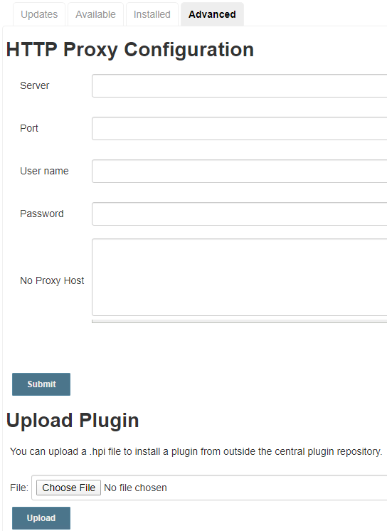

* “Available” is the option to check the available plugins which are not installed
* “installed” is the option to check the already installed plugins
* “updates” is used to find if any new updates are for the installed plugins
* We can also download the “.hpi” file of whatever version we want from Jenkins site and upload here under advanced option. This is also one way to install plugins

**Reload configuration:**

* **Reload configuration** helps to refresh the Jenkins



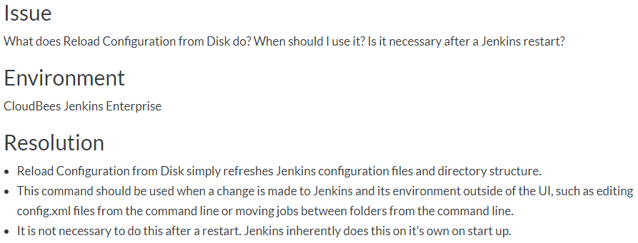

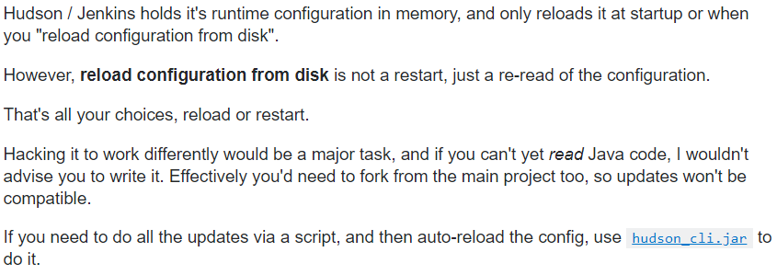

**Jenkins CLI:**

* **Jenkins command line interface** helps to use the Jenkins with CUI



**Prepare for shutdown:**

* **Prepare for shutdown** is like an alarm before we shutdown the Jenkins, Jenkins won’t allow any builds if we enable this. And once we cancel this, all queued jobs will be executed



**Auto refresh:**

* We can enable the auto refresh option at the top right side of the page to refresh Jenkins for every few seconds

